


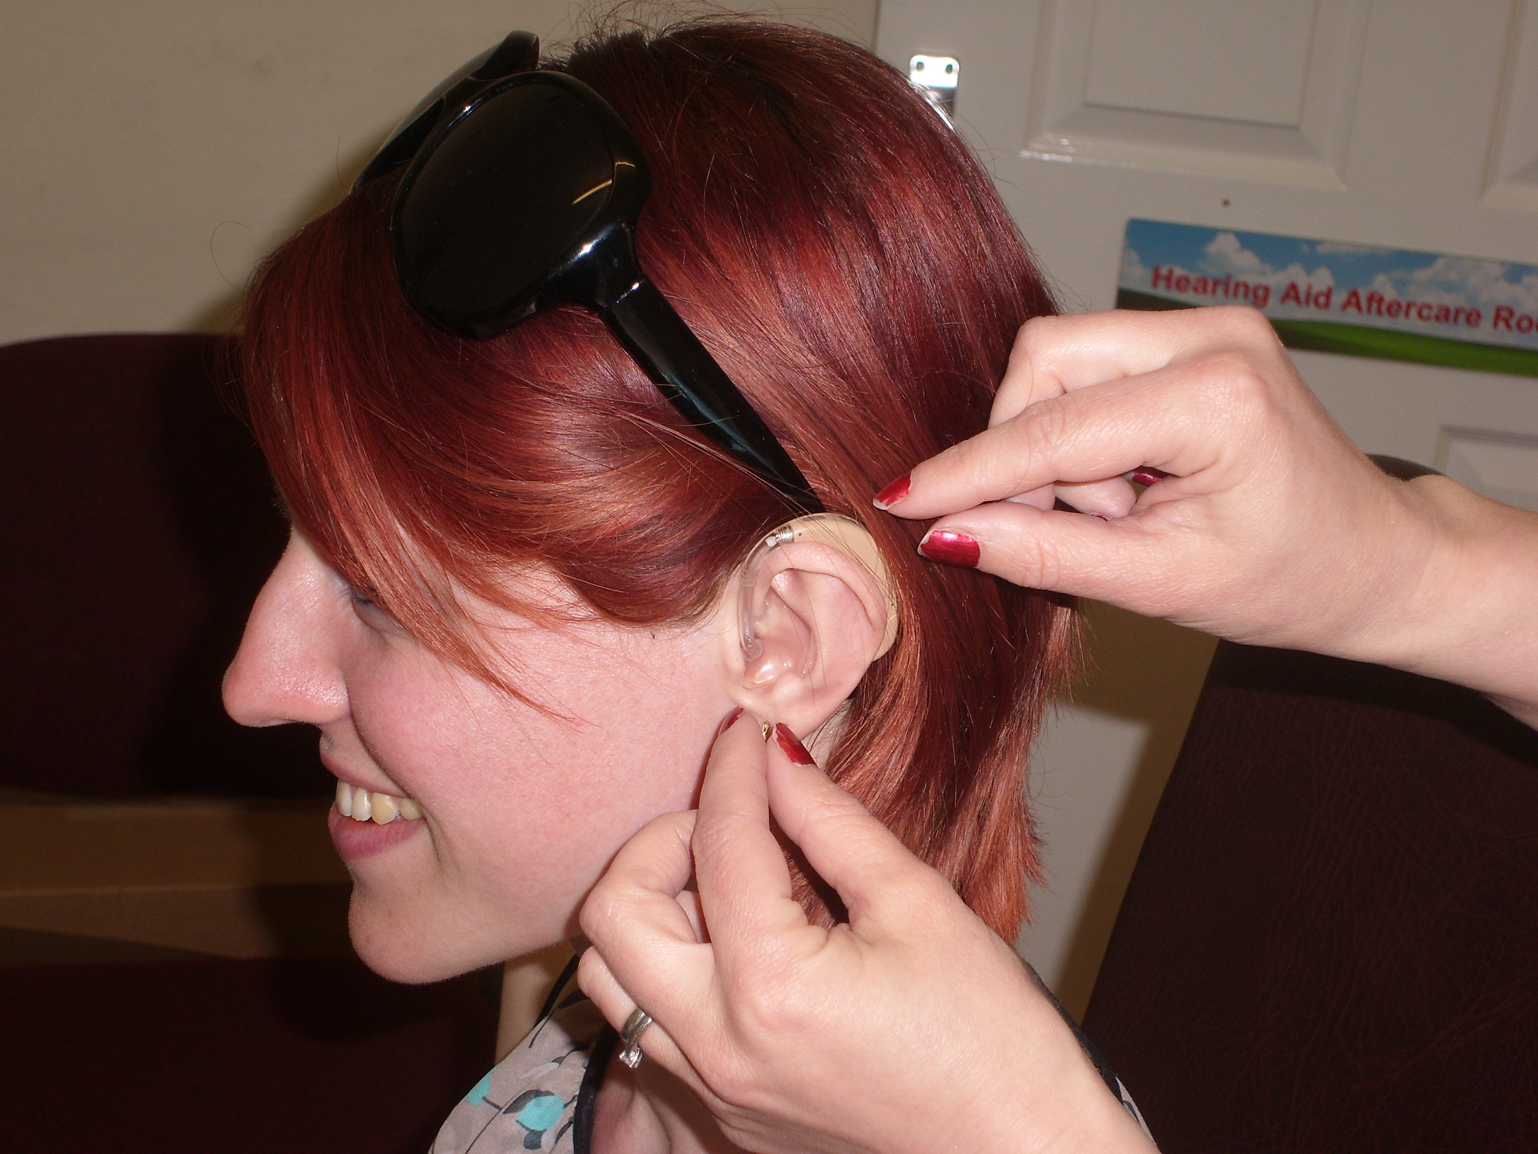
Hi Kent provides FREE NHS hearing aid aftercare, advice and battery supply
Head Office & West Kent Centre:
18 Brewer Street, Maidstone, ME14 1RU
Tel: 01622 691151 www.hikent.org.uk

The Queen’s Award for Voluntary
Service 2007

THE LOCAL CHARITY FOR PEOPLE WITH A HEARING LOSS

Your local clinic is held at:
Wellfield Community Hall
Wellfield
Hartley, DA3 7EG

2025 Clinic Dates:- Monday
6th January 7th July
3rd February 4th August
3rd March 1st September
7th April 6th October
No clinic May 3rd November
2nd June 1st December

10.00 – 11.30 am



